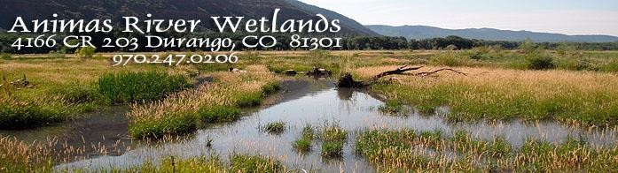
Animas River Wetlands Bird List 2009-2015
Beginning in 2009, members of the Durango Bird Club have visited Animas River Wetlands yearly in September. This is a cumulative list of birds.

- Great Blue Heron
- Canada Goose
- Mallard
- Green Winged Teal
- Common Merganser
- American Coot
- Osprey
- American Kestrel
- Red-tailed Hawk
- Sharp-shinned Hawk
- Ferruginous Hawk
- Cooper’s Hawk
- Spotted Sandpiper
- Wilson’s Snipe
- Northern Flicker
- Lewis’s Woodpecker
- Downy Woodpecker
- Harry’s Woodpecker
- Red-Naped Sapsucker
- Western Wood-Pewee
- Western Kingbird
- Belted Kingfisher
- Loggerhead Shrike
- Warbling Vireo
- Steller’s Jay
- Clark’s Nutcracker
- Black-billed Magpie
- Common Raven
- American Crow
- Kill Deer
- Rock Pigeon
- Great Horned Owl
- Brown Creeper
- House Wren
- Rock Wren
- Western Meadowlark
- Ruby-crowned Kinglet
- American Robin
- Western Bluebirds
- Mountain Bluebirds
- Sage Thrasher
- Orange-crowned Warbler
- Yellow-Rumped Warbler
- MacGillivray’s Warbler
- Wilson’s Warbler
- Common Yellowthroat
- Lazuli Bunting
- Green-tailed Towhee
- Chipping Sparrow
- Brewer’s Sparrow
- Vesper Sparrow
- White-crowned Sparrow
- Song Sparrow
- Lincoln’s Sparrow
- House Sparrow
- Violet-green Swallow
- Northern Rough-winged Swallow
- Barn Swallow
- Cliff Swallow
- Tree Swallow
- European Starling
- Western Meadowlark
- Yellow-headed Blackbird
- Red-winged Blackbird
- Brewer’s Blackbird
- Evening Grosbeak
- House Finch
- Lesser Goldfinch
- American Goldfinch
- Pine Siskin
- Black-capped Chickadee
- Whited Breasted Nuthatch
- Blue-gray Gnatcatcher

- European Collared Dove
- Say’s Phoebe
- Rufous Hummingbird

The new birds for 2014 were American Coot, Green Winged Teal, and Rock Pigeon.

The new birds seen in 2015 were Cooper’s Hawk, Harry Woodpecker, Say’s Phoebe, Blue-gray gnatcatcher. Belted kingfisher, European Collared dove and Rufous Hummingbird.

Other birds seen at different times of the year:
Bald Eagle
Golden Eagle
Turkey Vulture
Brown headed Cow Birds
Northern Harrier
Snowy Egret
White Face Ibis
Prairie Falcon seen on October 19, 2015—Bird Mentoring Group

Wild Turkeys seen in April 2016
Great Egert-May 2016

For a total of 86 different species.

